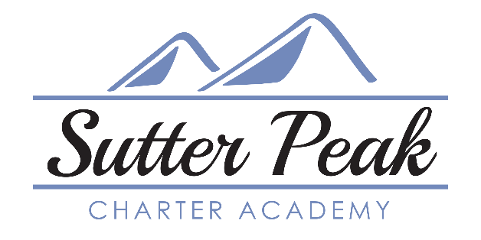

Social Studies Curriculum Guide
Cost Key: $ under $100 $$ $100-$150 $$$ $150-$200 $$$$ over $200

Studies Weekly   | Grades | Format | Cost | Vendor
 | TK-8 | Online  Printed Materials | $ | 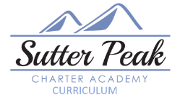
SPCA Curriculum! Student-friendly and standards-aligned core curriculum that is organized thematically to the strands of civics and government, geography, economics, and history. Two options: student-friendly weekly printed periodical format or friendly, motivating online learning platform that includes videos, tutorials, and text to speech option. Open-and-Go format that is paced out as one lesson a week for the year. https://store.studiesweekly.com/n-social-studies/CA/0/en

Bright Thinker | Grades | Format | Cost | Vendor
 | 6-12 | Textbook, workbook  Online option | $$ - print  $$$$ - online
SPCA Curriculum! For families that want a print-only curriculum and/or high school students. 10 workbooks cover the year’s learning. Lesson format is traditional with informational texts/chapters to read with follow-up questions and short written activities followed by quizzes and unit tests. Standards-aligned, paced for the school year. Teacher/parent edition includes answer keys. Same course available online but only makes sense if student is enrolling in multiple Bright Thinker courses, as cost is $295 per student per year for unlimited courses. https://brightthinker.com/

Edmentum Courseware | Grades | Format | Cost | Vendor
 | 6-12 | Online | $
SPCA curriculum! Digital curriculum. Videos for most lessons, short texts to read. Follow-up questions, written activities, and tests. Text to speech feature offered. Pacing built into the curriculum. Guided notes can be printed and added to throughout each unit and used on the assessments. Glossary of terms for each unit. Can be adjusted/modified for student needs. https://www.edmentum.com/products/courseware

Story of the World | Grades | Format | Cost | Vendor
Story of the World | 3-6 | Textbook, Workbook, CDs | $ | No
Narrative formatted textbook works together with the student Activity Book, maps, extension activities, and optional tests. Audiobook CDs test book available.4-volume series that guides students, story-by-story, through chronological world history. Volume 1: Ancient Times, Volume 2: Middle Ages, Volume 3: Early Modern Times, Volume 4: Modern Age. With adaptations, works for multi-level/multi-age learning. Not a traditional textbook. Can start with any volume; guided note-taking in the last volume. Not standards aligned. Can be ordered through SPCA Vendors (i.e., A Brighter Child, Rainbow Resource, etc.) https://welltrainedmind.com/landing/story-of-the-world/?v=7516fd43adaa

MULTI-SUBJECT PROGRAMS WITH HISTORY COMPONENT

Time4Learning | Grades | Format | Cost | Vendor
 | TK-12 | Online | $$$S | Yes
This curriculum makes sense for social studies if a student is using Time4Learning for 3 other courses, as the price is $29.95/month (or $300 for the school year) for 4 courses. All instruction online through engaging videos and clear tutorials. Parents have a login to set up lesson plans and assignments, as well as access records of student work. Can select default grade-level course or customize for student’s needs. https://www.time4learning.com/

Book Shark | Grades | Format | Cost | Vendor
Book Shark | TK-10 | Printed Materials  Online Resources | $$$$ | Yes
History is included when you purchase their All-Subjects or Reading Plus History program. History, geography, read-alouds, and readers are integrated with Language Arts, creating a cohesive learning experience. Literature and discussion based approach that is integrated around historical themes. Parents appreciate: weekly overviews, daily lesson plans, scripted instruction, and grading rubrics. Note: this curriculum contains a HIGH volume of reading! Readings (fiction, non-fiction, biographies, etc.) are scheduled into the Instructor’s Guide. https://www.bookshark.com/

